**Searching Algorithms To Implement In C**

**Linear Search**

The steps used in the implementation of Linear Search are listed as follows -

* First, we have to traverse the array elements using a **for** loop.
* In each iteration of **for loop,** compare the search element with the current array element, and -
  + If the element matches, then return the index of the corresponding array element.
  + If the element does not match, then move to the next element.
* If there is no match or the search element is not present in the given array, return **-1.**

### Algorithm

1. Linear_Search(a, n, val) // 'a' is the given array, 'n' is the size of given array, 'val' is the value to search
2. Step 1: set pos = -1
3. Step 2: set i = 1
4. Step 3: repeat step 4 while i **<**= n
5. Step 4: if a[i] == val
6. set pos = i
7. print pos
8. go to step 6
9. [end of if]
10. set ii = i + 1
11. [end of loop]
12. Step 5: if pos = -1
13. print "value is not present in the array "
14. [end of if]
15. Step 6: exit

## Working of Linear search

Now, let's see the working of the linear search Algorithm.

To understand the working of linear search algorithm, let's take an unsorted array. It will be easy to understand the working of linear search with an example.

Let the elements of array are -

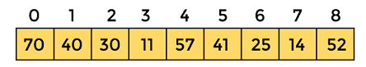

Let the element to be searched is **K = 41**

Now, start from the first element and compare **K** with each element of the array.

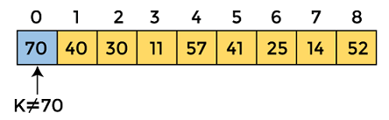

The value of **K,** i.e., **41,** is not matched with the first element of the array. So, move to the next element. And follow the same process until the respective element is found.

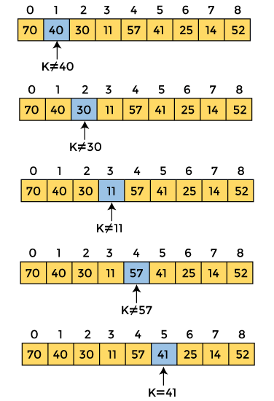

Now, the element to be searched is found. So algorithm will return the index of the element matched.

## Linear Search complexity

Now, let's see the time complexity of linear search in the best case, average case, and worst case. We will also see the space complexity of linear search.

### Time Complexity

|  |  |
| --- | --- |
| **Case** | **Time Complexity** |
| **Best Case** | O(1) |
| **Average Case** | O(n) |
| **Worst Case** | O(n) |

* **Best Case Complexity -** In Linear search, best case occurs when the element we are finding is at the first position of the array. The best-case time complexity of linear search is **O(1).**
* **Average Case Complexity -** The average case time complexity of linear search is **O(n).**
* **Worst Case Complexity -** In Linear search, the worst case occurs when the element we are looking is present at the end of the array. The worst-case in linear search could be when the target element is not present in the given array, and we have to traverse the entire array. The worst-case time complexity of linear search is **O(n).**

The time complexity of linear search is **O(n)** because every element in the array is compared only once.

### Space Complexity

|  |  |
| --- | --- |
| **Space Complexity** | O(1) |

* The space complexity of linear search is O(1).

**Program:**

#include <stdio.h>

**int** linearSearch(**int** a[], **int** n, **int** val) {

  // Going through array sequencially

**for** (**int** i = 0; i < n; i++)

    {

**if** (a[i] == val)

**return** i+1;

    }

**return** -1;

}

**int** main() {

**int** a[] = {70, 40, 30, 11, 57, 41, 25, 14, 52}; // given array

**int** val = 41; // value to be searched

**int** n = **sizeof**(a) / **sizeof**(a[0]); // size of array

**int** res = linearSearch(a, n, val); // Store result

  printf("The elements of the array are - ");

**for** (**int** i = 0; i < n; i++)

  printf("%d ", a[i]);

  printf("\nElement to be searched is - %d", val);

**if** (res == -1)

  printf("\nElement is not present in the array");

**else**

  printf("\nElement is present at %d position of array", res);

**return** 0;

}

**Output:**

Linear Search Algorithm

# Binary Search

* In this article, we will discuss the Binary Search Algorithm. Searching is the process of finding some particular element in the list. If the element is present in the list, then the process is called successful, and the process returns the location of that element. Otherwise, the search is called unsuccessful.
* Linear Search and Binary Search are the two popular searching techniques. Here we will discuss the Binary Search Algorithm.
* Binary search is the search technique that works efficiently on sorted lists. Hence, to search an element into some list using the binary search technique, we must ensure that the list is sorted.
* Binary search follows the divide and conquer approach in which the list is divided into two halves, and the item is compared with the middle element of the list. If the match is found then, the location of the middle element is returned. Otherwise, we search into either of the halves depending upon the result produced through the match.

## Algorithm

1. Binary_Search(a, lower_bound, upper_bound, val) // 'a' is the given array, 'lower_bound' is the index of the first array element, 'upper_bound' is the index of the last array element, 'val' is the value to search
2. Step 1: set beg = lower_bound, end = upper_bound, pos = - 1
3. Step 2: repeat steps 3 and 4 while beg **<**=end
4. Step 3: set mid = (beg + end)/2
5. Step 4: if a[mid] = val
6. set pos = mid
7. print pos
8. go to step 6
9. else if a[mid] **>** val
10. set end = mid - 1
11. else
12. set beg = mid + 1
13. [end of if]
14. [end of loop]
15. Step 5: if pos = -1
16. print "value is not present in the array"
17. [end of if]
18. Step 6: exit

## Working of Binary search

Now, let's see the working of the Binary Search Algorithm.

To understand the working of the Binary search algorithm, let's take a sorted array. It will be easy to understand the working of Binary search with an example.

There are two methods to implement the binary search algorithm -

* Iterative method
* Recursive method

The recursive method of binary search follows the divide and conquer approach.

Let the elements of array are -

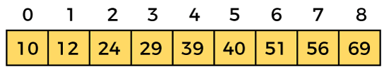

Let the element to search is, **K = 56**

We have to use the below formula to calculate the **mid** of the array -

1. mid = (beg + end)/2

So, in the given array -

**beg** = 0

**end** = 8

**mid** = (0 + 8)/2 = 4. So, 4 is the mid of the array.

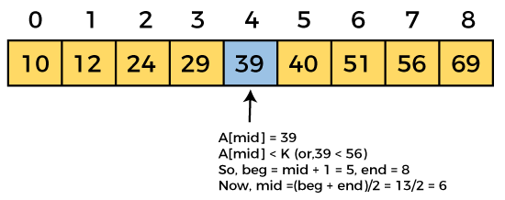  
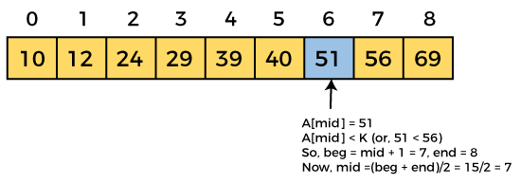  
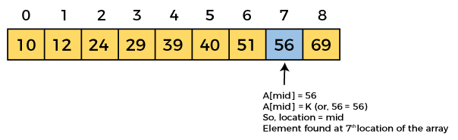

Now, the element to search is found. So algorithm will return the index of the element matched.

## Binary Search complexity

Now, let's see the time complexity of Binary search in the best case, average case, and worst case. We will also see the space complexity of Binary search.

### 1. Time Complexity

|  |  |
| --- | --- |
| **Case** | **Time Complexity** |
| **Best Case** | O(1) |
| **Average Case** | O(logn) |
| **Worst Case** | O(logn) |

* **Best Case Complexity -** In Binary search, best case occurs when the element to search is found in first comparison, i.e., when the first middle element itself is the element to be searched. The best-case time complexity of Binary search is **O(1).**
* **Average Case Complexity -** The average case time complexity of Binary search is **O(logn).**
* **Worst Case Complexity -** In Binary search, the worst case occurs, when we have to keep reducing the search space till it has only one element. The worst-case time complexity of Binary search is **O(logn).**

### 2. Space Complexity

|  |  |
| --- | --- |
| **Space Complexity** | O(1) |

* The space complexity of binary search is O(1).

**Program:**

#include <stdio.h>

**int** binarySearch(**int** a[], **int** beg, **int** end, **int** val)

{

**int** mid;

**if**(end >= beg)

    {        mid = (beg + end)/2;

/* if the item to be searched is present at middle */

**if**(a[mid] == val)

        {

**return** mid+1;

        }

            /* if the item to be searched is smaller than middle, then it can only be in left subarray */

**else** **if**(a[mid] < val)

        {

**return** binarySearch(a, mid+1, end, val);

        }

            /* if the item to be searched is greater than middle, then it can only be in right subarray */

**else**

        {

**return** binarySearch(a, beg, mid-1, val);

        }

    }

**return** -1;

}

**int** main() {

**int** a[] = {11, 14, 25, 30, 40, 41, 52, 57, 70}; // given array

**int** val = 40; // value to be searched

**int** n = **sizeof**(a) / **sizeof**(a[0]); // size of array

**int** res = binarySearch(a, 0, n-1, val); // Store result

  printf("The elements of the array are - ");

**for** (**int** i = 0; i < n; i++)

  printf("%d ", a[i]);

  printf("\nElement to be searched is - %d", val);

**if** (res == -1)

  printf("\nElement is not present in the array");

**else**

  printf("\nElement is present at %d position of array", res);

**return** 0;

}

**Output:**

Binary Search Algorithm